**Cover Nacelle Gamesa G80**

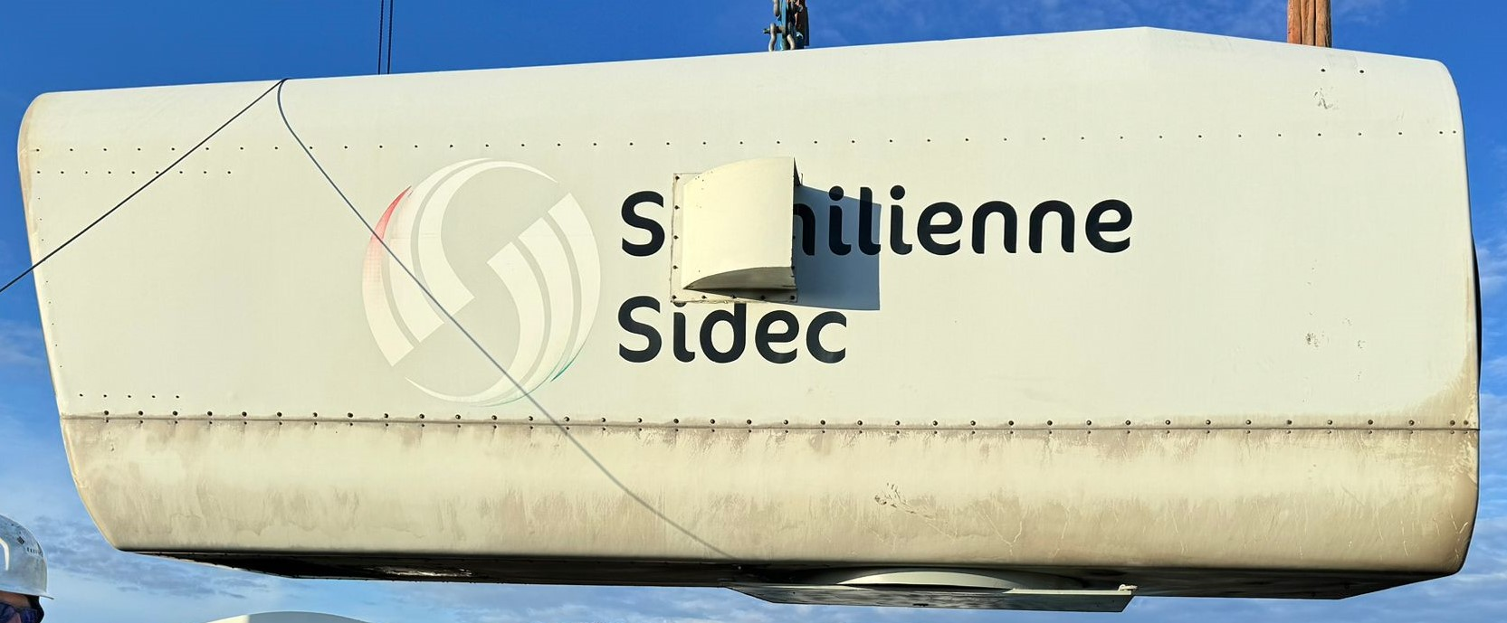

*Ref.Nº*: **634**

Pieces ….

Turbine …..

Power …

Rotor diameter …

Tower Hight ……..

Year ……….

Maintenance ……….

Condition ………..

Location ……..

Availability ………

Price: ***7.595.-€* per piece** / **Included dismantling + Loaded on Truck**